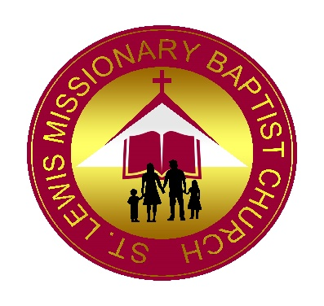
The Congregation of St. Lewis Missionary Baptist Church, founded in 1874 and located in Duplin County in the town of Chinquapin, North Carolina, is currently seeking a spiritually mature and devoted servant of God who is biblically called, qualified, and experienced to serve the Lord as our Pastor.
Our congregation is primarily composed of middle-aged to senior adults, and we have a strong desire to grow our ministry by attracting and engaging youth and young adults. Sunday School begins at 9:45 a.m., followed by Worship Service at 11 a.m. on the first and third Sundays of each month. Prayer Ministry and Bible Study are held weekly on Wednesdays at 7:30 p.m.
QUALIFICATIONS
- The successful candidate must be licensed and ordained and possess, at minimum, experience in a theological setting.
- Must live within an 80-mile radius of the church.
- Must have a flexible schedule to effectively teach and preach the Gospel, grounded in a thorough knowledge of the Bible through formal training and demonstrated experience.
- Must be able to communicate effectively with church members, the local community, and affiliated organizations.
- Must possess practical knowledge of technology tools to enhance ministry and communication.
RESPONSIBILITIES
- The Pastor, called by God, shall lead the congregation into a closer relationship with the Lord.
- Provide leadership that promotes spiritual growth, membership retention, and church growth, with special emphasis on youth and young adults.
- Be actively involved in community outreach, missions, social activities, and volunteer opportunities.
- Perform pastoral duties including visitation, counseling, baptisms, funerals, communion, baby dedications, weddings, and other related responsibilities such as choir and usher anniversaries, ect.
HOW TO APPLY
Applicants should submit:
- A cover letter stating interest
- A current résumé
- Copies of ministerial license and ordination certificate
- Sealed copies of college and seminary transcripts, as applicable
- At least three letters of reference, including:
  - A moderator or religious equivalent
  - A home church, church of affiliation, or current pastoral church
  - An immediate family member such as spouse, children, parents, or siblings
Final candidates must consent to a criminal background check.
Letters of reference sent to Crystal Grant, 1977 Ferbow Street, Creedmoor, NC 27522
Cover letters, resume’, copies of ministerial license and ordination certificate as well as college and seminary transcripts should be sent to the encrypted email of crystalgrant@awaycounseling.com
All information must be submitted by March 10, 2026. Incomplete application packets will not be reviewed.
Best,

Crystal P. Grant, Chiquitta W. Lesene, and the Pastoral Search Committee

