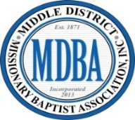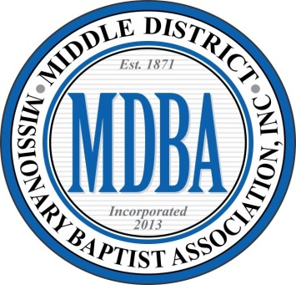C:\Users\Laverne\AppData\Local\Microsoft\Windows\Temporary Internet Files\Content.IE5\QZF7EHUQ\MC900048038[1].wmf1821 NC Hwy 53 West

**Dr. Reginald A. Wells, Moderator**

Reverend David Smith, First Vice-Moderator

Reverend Frederick McLean, Second Vice-Moderator

November 14, 2023

**MIDDLE DISTRICT MISSIONARY BAPTIST ASSOCIATION**

**NOTICE OF INTENT OF CANDIDACY**

**2024-2028 ELECTION**

Good morning pastors, officers, and members,

As you know the constitution of the Middle District Baptist Association mandates that we have an annual election every four years. Next year (2024) is our election year.

Any member interested in being considered a candidate for any office in this Association MUST submit the following documents to Dr. Terry L. Henry on or before December 31, 2023. A Letter of Intent, resume, and a letter from his/her church indicating candidate's status in his/her church.

Dr. Henry and the Nominating Committee will verify the credentials and qualifications of each candidate.  The Nominating Committee will also verify that the candidate's church has met its financial obligations (Quota met for past two years; current and a completed Association profile letter).  If the candidate's church has not met its financial obligations to the Association, the candidate will be disqualified from seeking any elected office.

The Nomination Committee will prepare an election ballot to be available to Delegates at the Mid-Year Session (March).  Sample election ballots will be mailed to member churches in good financial standing on or before July 1st of the election year.

No person may hold an elected office in the Association without being an active member of a church (in good financial standing) belonging to this Association.

Elected Officers Positions:

Moderator

First Vice Moderator

Second Vice Moderator

Recording Secretary

Corresponding Secretary

Treasurer

Assistant Treasurer

Financial Secretary

Chairman of Trustee Board

Auditor

Parliamentarian

Please mail to:

Dr. Terry L. Henry

3308 Amber Dr.

Wilmington, NC 28409