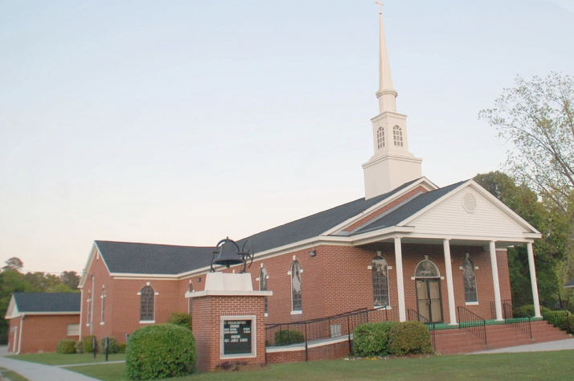
PASTORAL VACANCY
MT. PISGAH MISSIONARY BAPTIST CHURCH
312 N WRIGHT ST. BURGAW, NC 28425
The Congregation of Mt. Pisgah Missionary Baptist Church founded in 1892 and located in Pender County in the town of Burgaw, NC is currently seeking a spiritually mature and devoted servant of God, who is biblically called, qualified, and experienced to serve the Lord as our Pastor. The congregation primarily consists of middle aged to senior adults and we are seeking more youth and young adults. Our Sunday School begins at 10:00 a.m. and our worship service is at 11:00 a.m. on the 1st through the 4th Sunday of each month. Bible Study is every Wednesday at 7:00 p.m.
QUALIFICATIONS
- The successful candidate for Pastor must have, as a minimum, a bachelor’s degree, and some theological studies.
- Live within an 80-mile radius of the church.
- Have a time schedule sufficiently flexible to teach and preach the gospel based on a thorough knowledge of the Bible gained through formal training and demonstrated experience.
- Effectively communicate with the varied membership, the community and other church affiliated organizations.
- A practical knowledge of technological tools available to enhance the communication process.
RESPONSIBILITIES
- The Pastor called by God shall help us to thrive and lead our congregation to a closer relationship with the Lord.
- Actively lead the spirituality, retention, and growth of our membership with a special emphasis on young adults and youth.
- Be involved in community outreach, social activities, mission, and volunteer opportunities that allow the congregation to get to know the community.
- Duties will also include visitation, counseling, performing baptisms, funerals, administering communion, baby dedications, weddings, and other related pastoral duties.
HOW TO APPLY
Submit a cover letter stating your interest and a current resume.
Copy of ministerial license and ordination certificate.
At least three letters of reference – 1) moderator or religious equivalent 2) a community member 3) letter of from home church or church of affiliation 4) personal reference.
FINAL CANDIDATES MUST CONSENT TO A CRIMINAL BACKGROUND CHECK.
To be considered, please mail your completed packet to: Mt. Pisgah Missionary Baptist Church Pastoral Selection Committee, c/o Mrs. Diane Murphy, Pulpit Chairperson, P. O. Box 1256, Burgaw, NC 28425
or email mtpisgahmbc.burgaw@gmail.com

RÉSUMÉ and the complete application packet should be postmarked and submitted by November 16, 2023.

