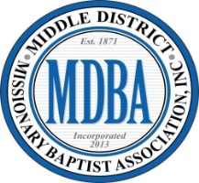
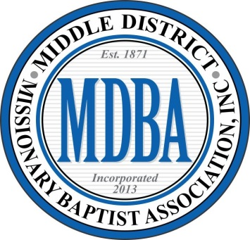
1821 NC Hwy 53 West Burgaw, NC 28425
middledistrictmba53@gmail.com
www.middledistrictmba.org

Reverend David Smith, Moderator Reverend Frederick McLean, First Vice-Moderator
Reverend Dr. Jeremy Buie, Second Vice-Moderator

2026 CALENDAR OF EVENTS

JANUARY 16th GBSC MLK Banquet (Greenville)
17th WBHFM Midyear Session (Greenville)

FEBRUARY 2nd-19th EWY Institute (Mon.-Thurs. Online) 6:45 P.M.
2nd-5th Missionary Institute (Mon.-Thurs.) 10:00 A.M.

MARCH 7th Deacons Academy 10:00 A.M.
13th Mid-Year Session/Lott Carey Day 10:00 A.M.
14th Deacons Academy 10:00 A.M.
28th Ministers, Deacons, & Ushers Union 10:00 A.M.

APRIL 10th Daughters of Zion Mid-Year 9:30 A.M.
(MDMBA State Missions Day)

MAY 2nd MDMBA Oratorical Contest 10:00 A.M.
30th Ministers, Deacons, & Ushers Union 10:00 A.M.
JUNE 21st Daughters Of Zion Summer Fest 1:00 P.M. TBA
26th State Oratorical Contest TBA

JULY 14th-15th Auxiliaries Annual Session 9:45 A.M.
18th Pastors Brunch 10:00 A.M.

AUGUST
29th Ministers, Deacons, & Ushers Union 10:00 A.M.

SEPTEMBER Moderator’s Banquet??? TBA

OCTOBER 8th & 9th Annual Session 9:45 A.M.
10th Youth Ministry Annual Session 10:00 A.M.
25th D.O.Z. Annual Candlelight March 4:00 P.M.

NOVEMBER 21st Making a Difference Day 10:00 A.M.
28th Ministers, Deacons, & Ushers Union 10:00 A.M.

DECEMBER 12th Gospel Musical Extravaganza 3:00 P.M. TBA

